Stakeholder management tools

STAKEHOLDERS | Project aims | End results | Issues | Changes | Delivery dates
Project Coordinator |  |  | I | D | D
School Champion
Project Partner
Project Team
End users
D = Decision I = Inform
Stakeholder mapping - power vs interest. Two similar models.
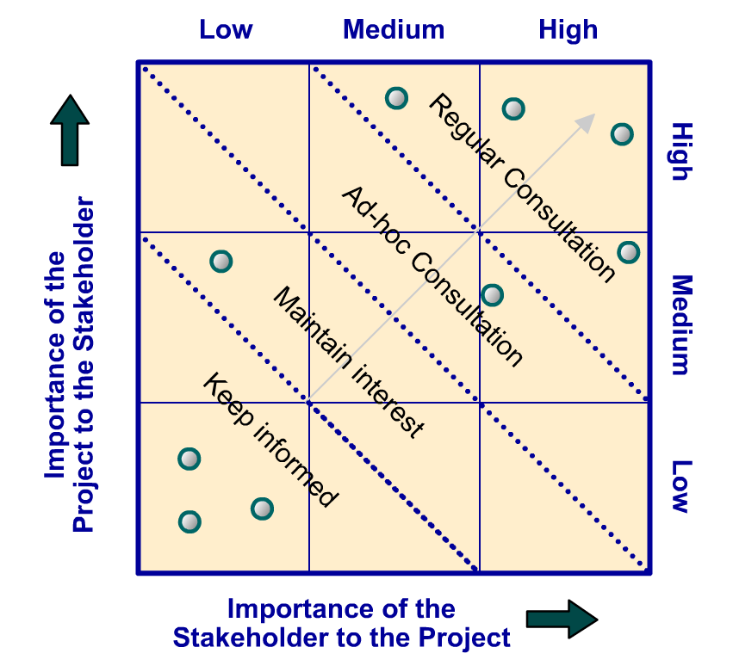
Influence/power of stakeholders | Keep satisfied  - Engage and consult on interest area  - Try to increase level of interest  - Aim to move into Key Player box | Key player – manage closely  - Focus efforts on this group  - Involve in decision making  - Engage and consult regularly
 | Keep informed  - Inform via general communications  - Aim to move into Show Consideration box | Show consideration/keep informed  - Make use of interest through involvement in low risk areas  - Keep involved & consult on interest area – may have useful information  - Potential supporter/goodwill ambassador
 | Interest of stakeholders
Interactive online version: https://www.mindtools.com/pages/article/newPPM_07.htm#Interactive

Stakeholder communications plan
Stakeholder | When/how often? | How?
Project Coordinator | At least weekly  When issues arise | Invite to weekly meetings, send copy of minutes - email  Email, phone call, text
School champion | Weekly | Send copy of minutes - email

Stakeholder review (traffic lights)
Stakeholder name:
Stakeholder expectations | R/A/G | Quick wins | Longer term issues/concerns
Use R/A/G to show how well stakeholder feels the project is doing against each criteria. Consider what can be done quickly to please each stakeholder (quick wins) and also what longer term issues they may have.

