The Mark Scott Leadership for Life Award
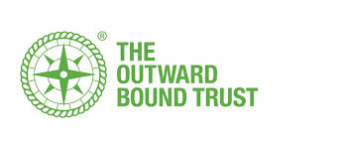
The Award, now over 20 years old, offers pupils the opportunity to build on their academic achievements in 6th year with a portfolio of real experiences, community action, and personal development.
We recruit in 5th year, from across the Central Belt, seeking pupils who can identify their own agenda for development. Whether it be to tackle social anxiety, to try to develop a leadership role, to boost personal confidence, to make new friends, or do something good for their community we are seeking young people with a willingness to invest a little in themselves, make some new strong friendships, have a good time and make a difference to themselves and others in the process.
The Award is recognised by employers and fully funded by Scottish Government, trusts, companies, and individuals who both recognise what we’ve been achieving, and also recognise the value in the graduates who have taken part.
This year we have an open recruitment policy, meaning that we can take applications through our website from any 5th year pupil in any school participating in the Award. All those interested need to do is go on to the website, check out the resources there (including films of past participants’ experiences) and fill in the short application form.
The Award costs only £30 for participants – the rest is fundraised for them.
Participation will see participants take part in a 5 day challenging outdoor residential training course in Autumn 2020, and then take part in weekly short meetings as they use their new skills and friendships to create a short project in their community which will benefit all.
This is a great way to finish the final year in school, developing confidence, skills useful in any future destination, and the ability to genuinely demonstrate the abilities of participants.
Please visit the website at mslfla.org to find out more, hear from past participants about their journey, and to make an application.
