PARTICIPANT INFORMATION AND JOINING INSTRUCTIONS
What to know before you go
In this leaflet you will find several really useful bits of information including:
- what to bring with you
- how to get to your residential

Please read and digest the information here: you will be better prepared for your week.
KIT LIST
This is an idea of some of the things you should consider bringing with you. Overall you should not need to buy anything specifically. Most clothing (apart from the clothes you may spend a short time in the evening wearing) will run the risk of getting dirty as you will be very active – so don’t bring your best stuff!
- Tee shirts
- Lunchbox if you are particular about this kind of thing
- Warm tops (thermals if you have them)
- Jumper / hoody
- Fleece if you have one
- Walking trousers / tracky bottoms (not all cotton ones) – NO JEANS
- Underwear
- Thick and thin walking socks – you may need to buy these if you don’t have any yet
- Jammies
- Shorts if you wish
- Teeshirt and shorts and swimming costume for doing water based activity, and a pair of old trainers that you can wear in the water too.
- Towel, washkit, etc.
- An additional pair of trainers
- Some comfortable clothes for the evenings and for coming home in.
Also:
- Sun-glasses if you have them
- Sun hat or baseball cap / snap-back in case it’s sunny
- Insect repellent
- Sun-cream (let’s be optimistic)

What NOT to bring
Valuables, wads of cash, jewellery, fancy phones, laptops, etc – you will be living communally so these items cannot be easily secured during your stay. They are also easy to lose or break; they’re just not worth it. Aerosols, penknives, alcohol and drugs are prohibited.
HOW TO GET TO LOCH EIL
Postcode: PH33 7NN
We have arranged for a coach to pick you up from central Glasgow on the Monday morning of your course. It will also return you there on the Friday afternoon. There will be no cost for you for this coach.
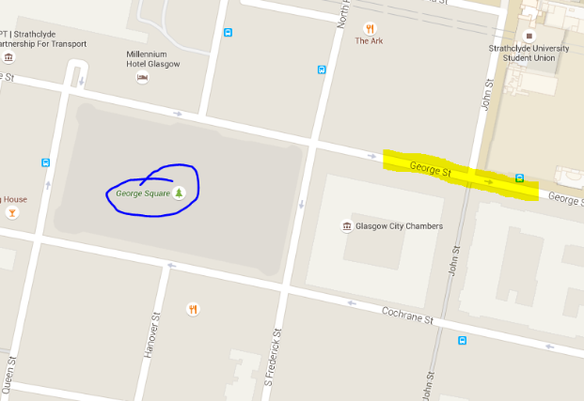
The coach will collect everyone at the bus stance on George Street just off George Square, Between N Frederick St and John St (in the highlighted area). It will leave promptly at 10am so please arrive by 09:30 in order to check in and be ready to go.
Queen Street Station
G1 1QX – Allander Coaches
If you have any problems on the way please call the centre on
01768 486 272
to let them know.

You will be dropped off at the same point at approximately 5:30pm on the Friday.
There should be a short stop on both journeys.
Please allow time for connections if you are travelling into the city from elsewhere – it might mean an early start, but will be better to be early than miss the bus.
If you intend to get to the centre on your own
Please let Steve know using the contact details below.
Other practical stuff you need to know
- You will need to bring a packed lunch with you to eat on the way as we will start the course as soon as you arrive.

- You will need to bring £10 as a returnable deposit for the equipment we will issue you at the start of your course – look after the kit and you’ll get it back on Friday.

- Mobile phones – basically hardly work. Please give your folks the centre telephone number above for emergencies, and tell them not to expect to hear from you during the week. Honestly reception is rubbish where we’re operating, but if they need to they can call the office during the week.

- Money – other than the deposit there is very little to spend your money on at the centre so don’t bother bringing much at all.

WHAT TO EXPECT
- You will be assigned a Project Coordinator - you can find their name if you check the timetable on the website. They will be your instructor for the week and will also support you through the whole of your Award experience in the following months.
- You will meet your Course Director, whose job it is to make things as smooth as possible for everyone, and who can talk to you if you are having any difficulties during the week
- You will be kept very active throughout the week, often working late into the evening
- You will be well fed
- You will have a nice comfortable bed in a small dormitory which you will share, most likely, with people from your group on a male or female only floor in the centre
- We will have a curfew, and we’ll also wake you up in the morning – there’s literally loads to do so we need to use every minute we’ve got!
- There will be an overnight expedition of some kind during the week – this is an amazing bonding experience for you and your team mates.

Your Project Coordinator
Will be a highly trained and highly experienced Outward Bound instructor, with a lot of experience in delivering community work (remember the community project). They are some of the best instructors Outward Bound has, and they are there for you.
They will:
- Give you responsibility for things you are capable of taking responsibility for
- Treat you with respect, and expect to be treated likewise
- Look out for you
- Allow you to make your own mistakes and help you to learn from them
- Support you throughout your whole experience
- Be prepared to do anything they ask you to do
- Challenge you and expect you to respond positively
- Allow you to deal with the consequences of your decisions and actions as an individual and as a team

To have a think about before you come:
- What do you want to get out of the course as a whole?
- What can you learn / gain from the Award?
- If you want to make a change – who do you want to be?
- Is there anyone you want to help for your community project that you are aware of already?
- Is there anything that you are aware of that your community needs?

Any problems or questions, please get in touch with Steve using the following methods:
Call 0141 413 5225 during office hours (not always manned) or 07776 177 469
Text 07776 177 469 at any time email steve.mackenzie@outwardbound.org.uk
Also – search for “The Mark Scott Leadership for Life Award 2016-17” on Facebook and ask to join the closed group – we’ll keep you posted of current events

