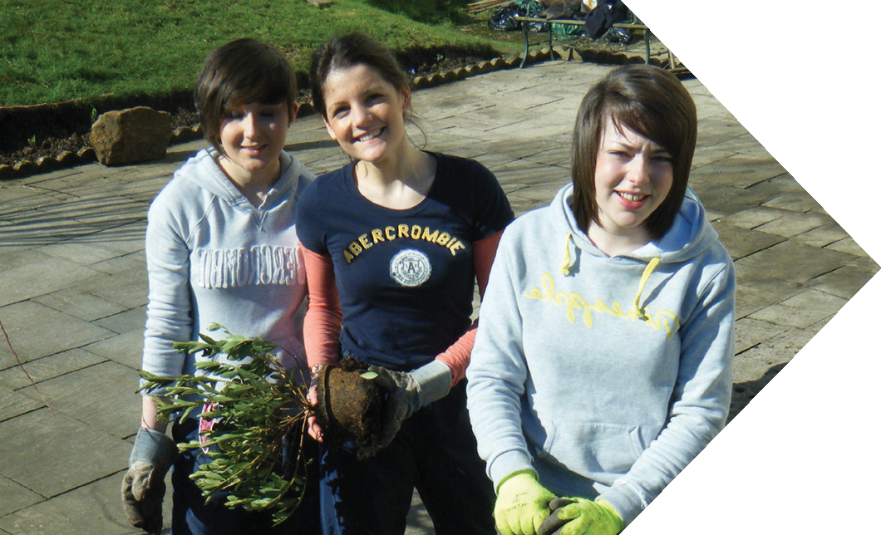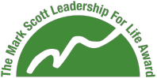

Community Research

Develop a sense of social responsibility by delivering projects that benefit your local community.
Use this worksheet to gain information about the needs of your community. Once complete, please use the information you’ve gathered to fill in the page in your online workbook.

 | Strengths  (What are the strengths of your community? What positive things are happening? What organisations are doing good work?) |  | Weaknesses  (What are the weaknesses within your community? What issues affect you or others? What do you think are the greatest  needs of your community?)
Opportunities  (What are the opportunites for a community project? Are there organisations you could work in partnership with? What would you like to see happen in your community?) |  | Threats  (What is happening in your community that has a negative impact on others? What issues affect you or your community? What would make it hard for you to work in your community?)

1 Local People

 Teacher / Headteacher  Religious leader (Immam / Rector/ Rabbi / Priest / Minister)
 Community Leader (MSP, Councillor)  Local co-ordinator (youth / Elderly group worker)
 Voluntary organisation  Local journalist
 Community worker (council)  Other

Job……………………………………………… Organisation………………………………
Name …………………………………………… Deadline …………………………………..

Organisations your contact has How can you help them ?
identified who need help

……………………………………………………… …………………………………………………………
……………………………………………………… …………………………………………………………
……………………………………………………… …………………………………………………………

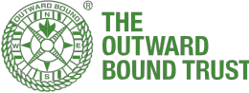

What partnership organisation could you work with in your community? (Please supply contact details)

Voluntary organisations

Schools

Youth groups

Religious groups

Community workers

Other

Do you have any family, friends or Neighbours who could benefit from help? Are there local services or local facilities that could benefit from a 3-day project?

