C:\Users\smackenzie\AppData\Local\Microsoft\Windows\Temporary Internet Files\Content.IE5\JNW36613\MC900188453[1].wmf

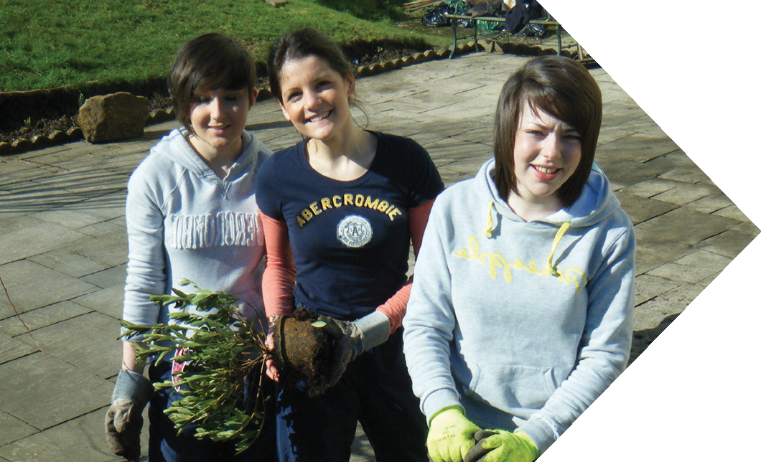

The Bridge Transfer of Learning Model

|  |  |  |
| --- | --- | --- |
| What did you do? | What did you learn? | How can you use this in Future? |
|  |  |  |
|  |  |  |
|  |  |  |
|  |  |  |
|  |  |  |
|  |  |  |
|  |  |  |
|  |  |  |



